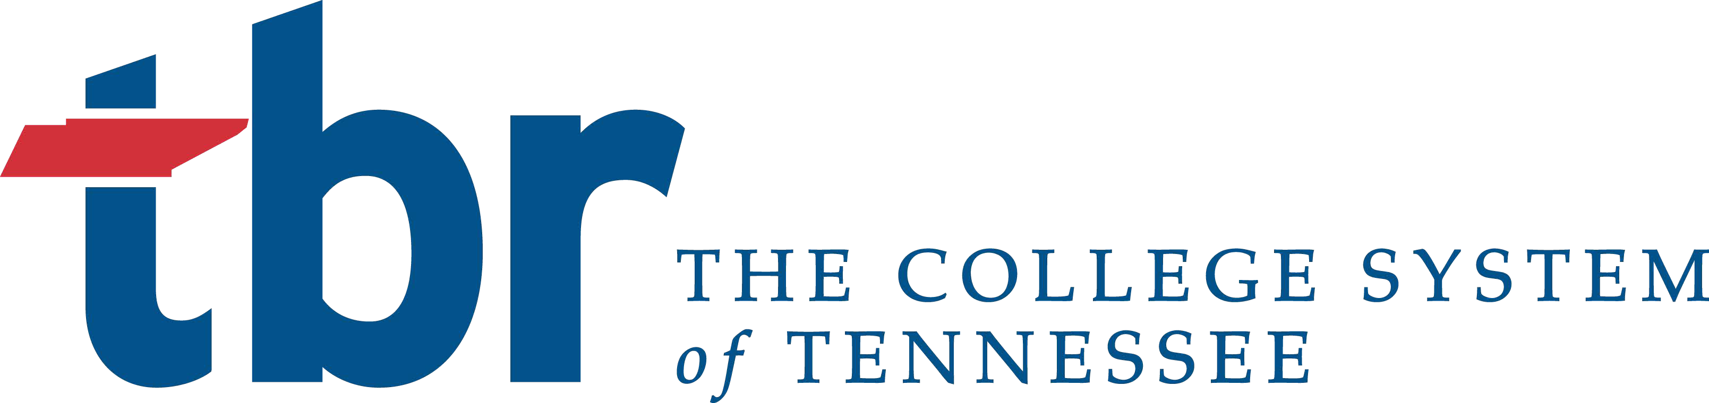

TENNESSEE BOARD OF REGENTS
1 Bridgestone Park, 3rd Floor
Nashville, Tennessee 37217
Phone (615) 366-4400

TITLE VI SURVEY

Declarations

Respondent- I declare that I have reviewed and approve the information provided in this self- survey and to the best of knowledge and belief, it is true, correct and complete

Name/Title: Click or tap here to enter text. Date: Click or tap here to enter text.

Institution: Click or tap here to enter text.

Signature: ___________________________________________________________________________

Administrative Head – I declare that I have reviewed and approved the information provided in this self-survey and to the best of my knowledge and belief, it is true, correct, and complete.

Name/Title: Click or tap here to enter text. Date: Click or tap here to enter text.

Signature: ___________________________________________________________________________

